Ego network exercise instructions – UCINET + Netdraw screen

Importing the excel file in UCINET
Data >import excel >matrices
(it saves the excel file as ucinet format – this file will be saved in some default folder whose name will be in the output file “ucinet logo-notepad”)

Below how does the data looks in UCINET
Matrix of relations – who knows whom
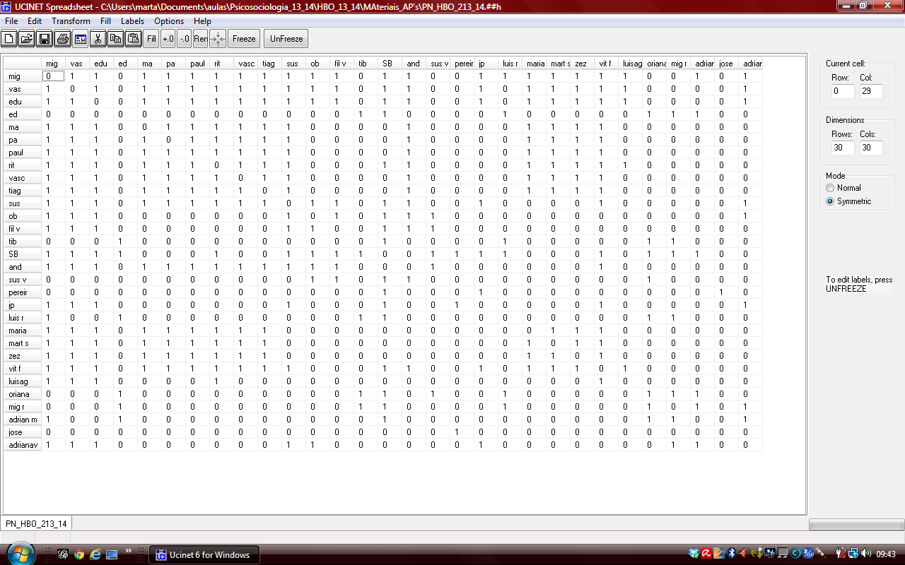

Excel file - Vectors with attributes : relation, place of living, social support
You import this excel file the same way, save it and call it another name

Netdraw instructions
Open netdraw; click the Little yellow folder on the left of the screen (below Edit) _ you will visualise the map of the matrix as shown below
-

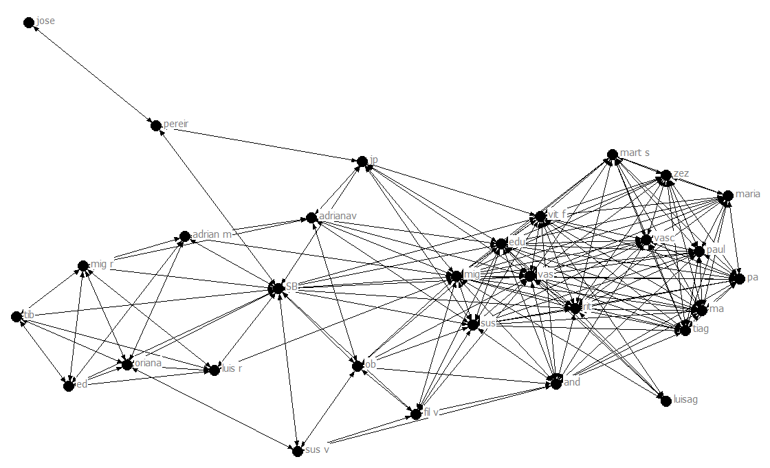

Next open the second ucinet file , the one with 5 columns : the labels (names of people) the relation (family, etc) the place of living (lisbon, etc), the category of age and the social support dimensions .
To import this second file Click the little folder with an A on the left side of the scree (located below Edit and Layout in the image above) NOTE : you will not see any new drawing this time!
Next : Then you click the Icon which has Little squares with different colours:
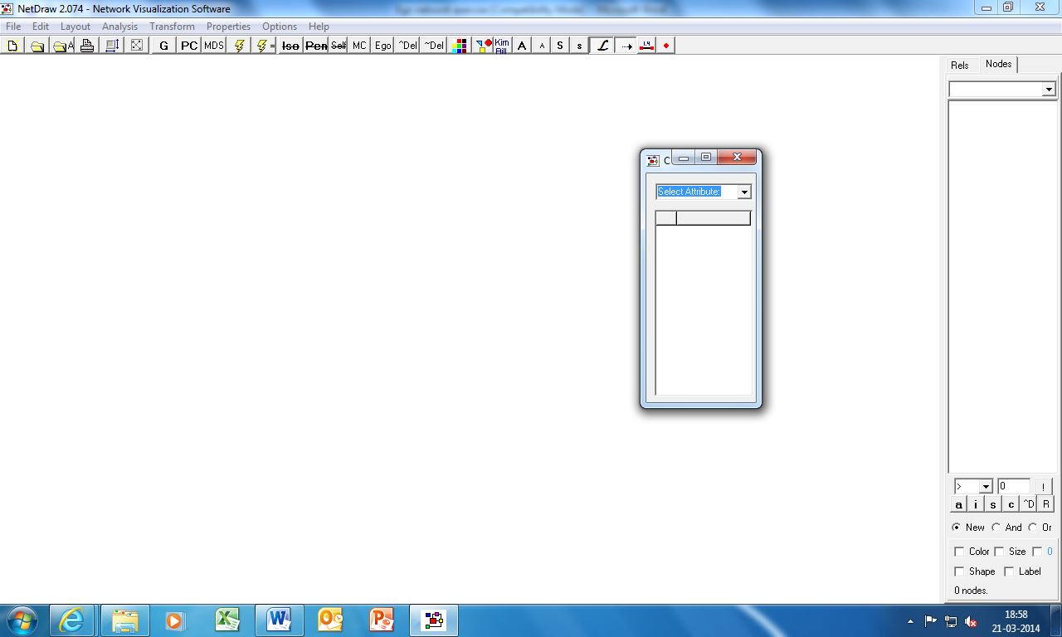
It will ask you to select attribute , and you select “relation”. The result will be that the round points (nodes) of the graph will change colours according to the relation of that person.
Next you select the icon with little shapes in it , of different colours. You select attribute “place of living” It will change the coloured nodes into different shapes according to the place of living of the person.
The graph will now allow to visualise your personal network differentiating the places of living (or age) + the type relationship
Next you go to properties Nodes symbols size attribute base and select your social support attribute. The size of symbols (nodes) will change size according to whether the person gives you 0 -5 social support.
You save the graph in JPEG format
File save diagram as Jpeg

Next :
We redo all this in order to obtain another visualization, this time with “age” replacing place of living

Again :
You save the graph in JPEG format
File save diagram as Jpeg

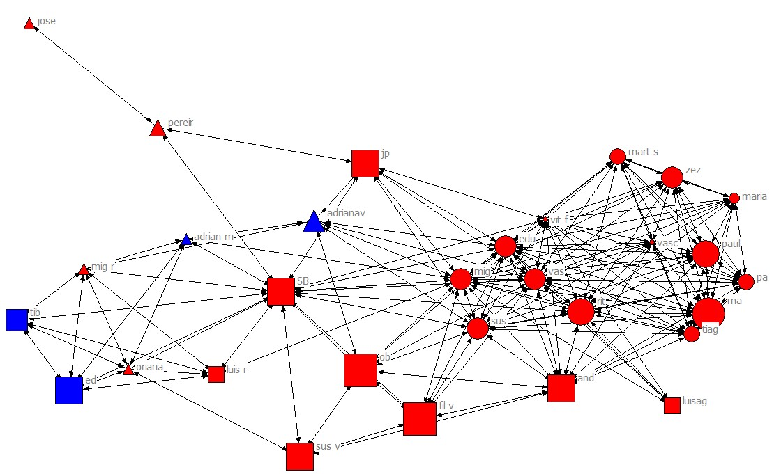

DONE!

